**Lab-Project 11: yesman--Scanner Honeypot with scapy**

**Finding the IP Address of the Target Machine**

**Finding the IP Address of the Target Machine**

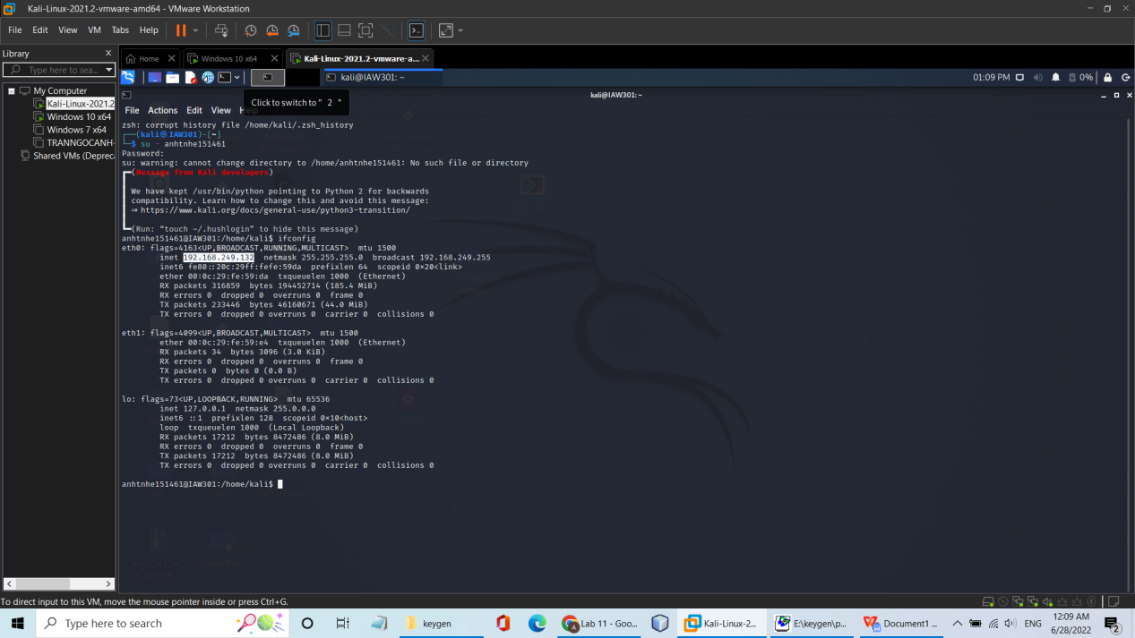

**Blocking ACK Packets on the Target Machine**

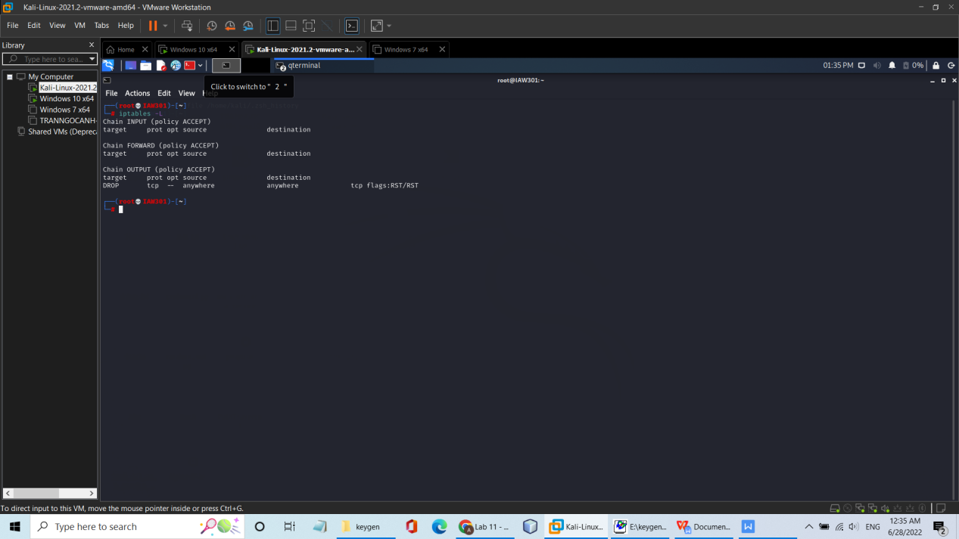

**Sniffing a Packet in scapy**

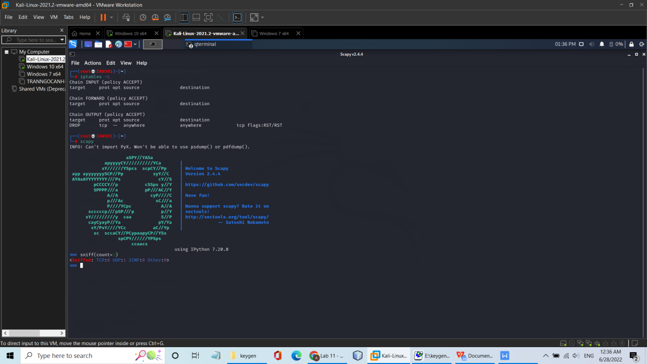

**Sniffing 100 Packets in scapy**

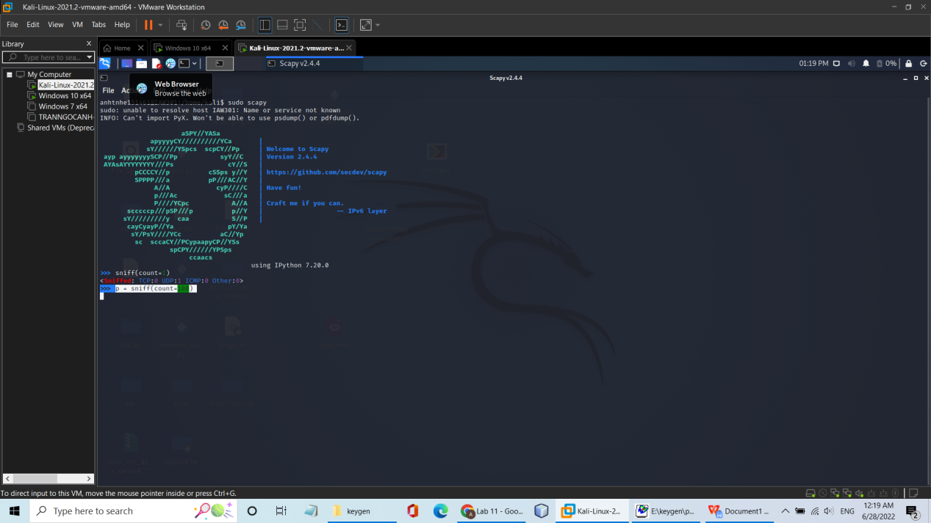

**Scanning from the Scanner Machine**

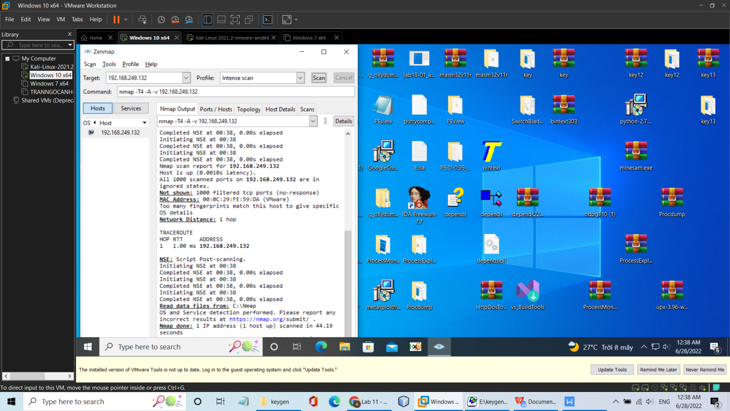

**Examining the Captured Packets**

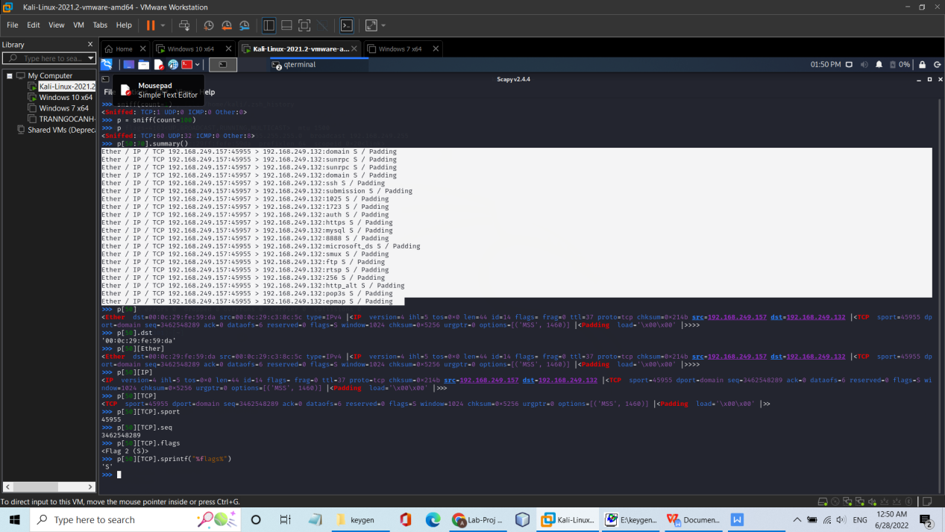

**Examining a TCP Packet**

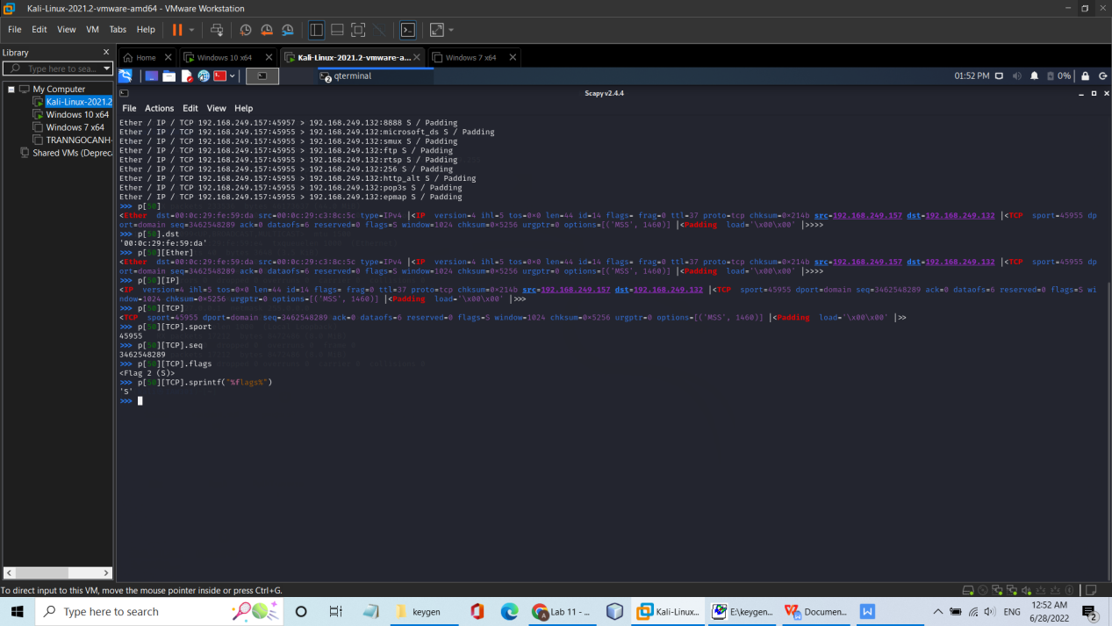

**Creating the yesman.py script**

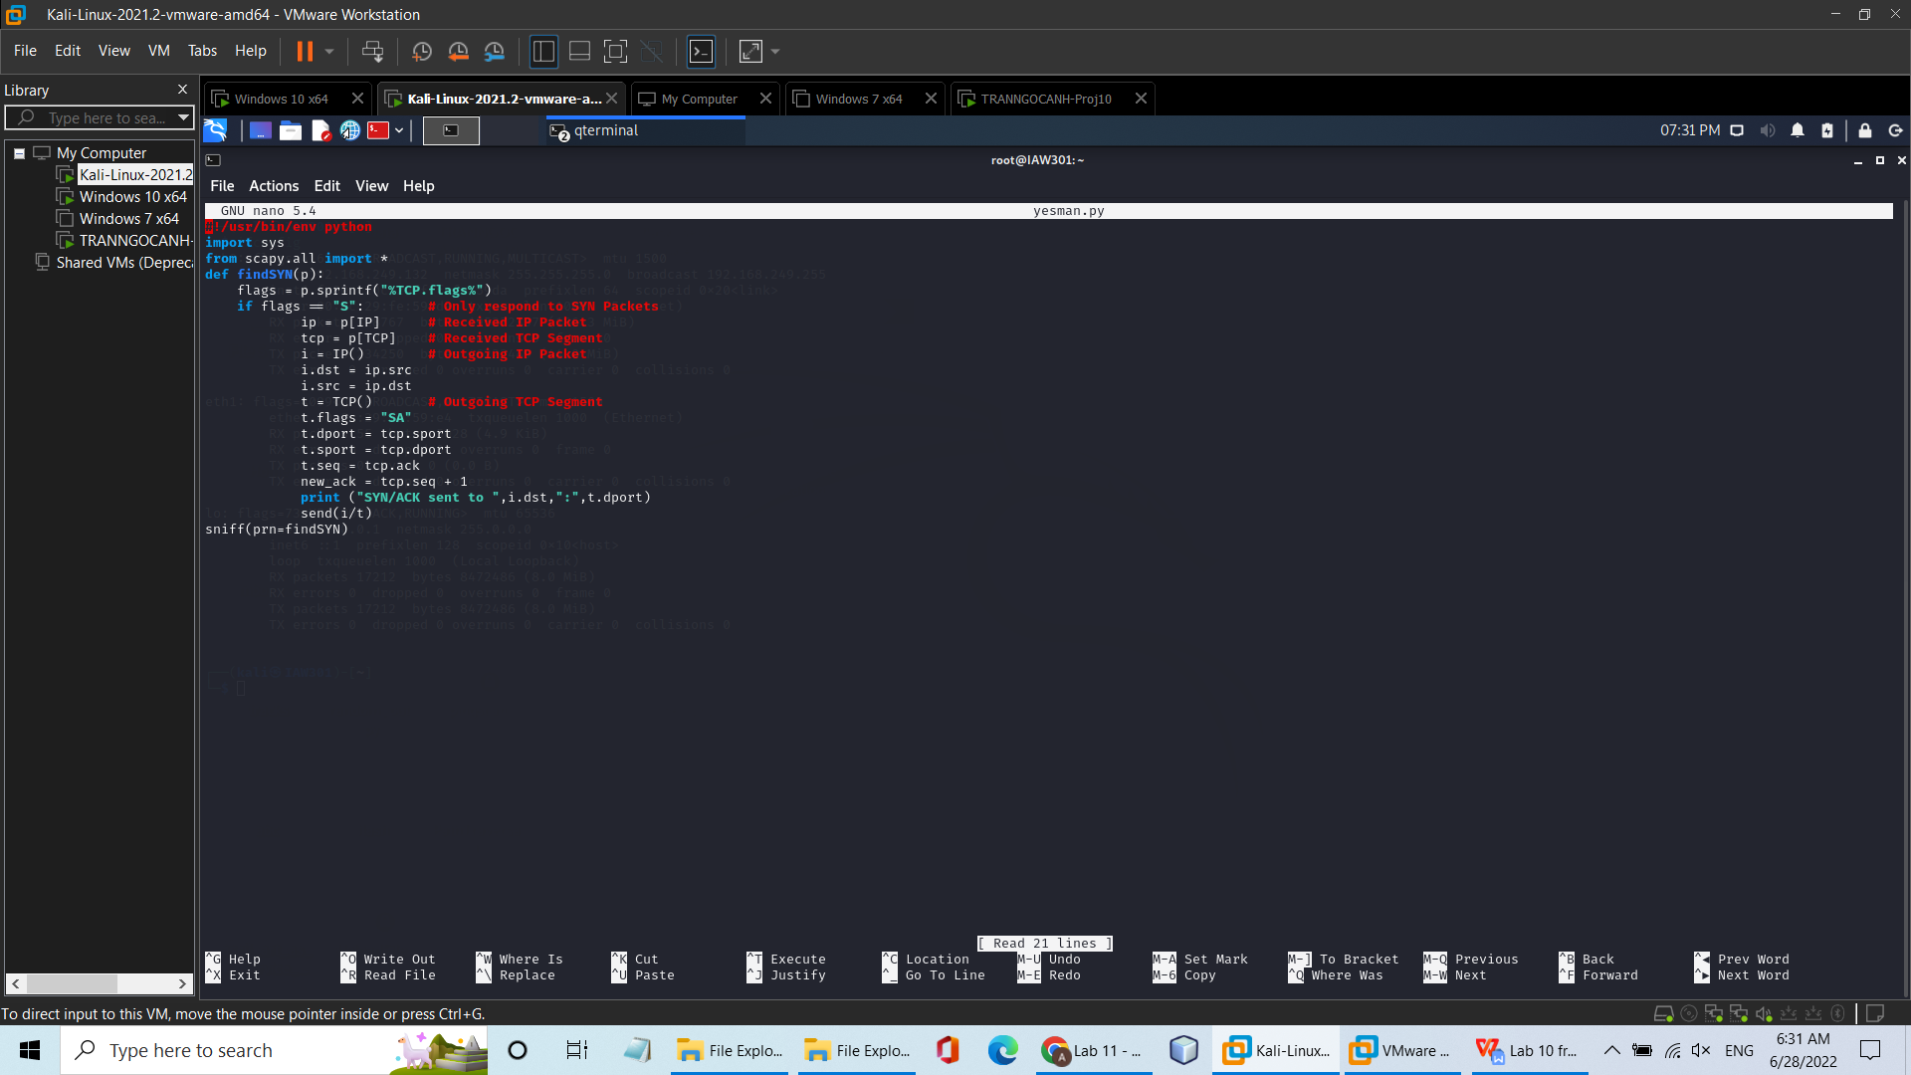

**Scanning the Protected Target Machine**

